**VPC (Virtual Private Cloud) Tutorial**

**Creating VPC with Public and Private subnets**

We will create one VPC and two subnets: i. public subnet (webserver) and ii. Private subnet (for database)

1. Public subnet: will have internet access
2. Private subnet: will not have internet access

VPC details:

VPC Name: MyVPC

CIDR : 10.0.0.0/16

Public Subnet: 10.0.1.0/24

Private Subnet: 10.0.2.0/24

#### Create VPC

Note: You will see default VPC, **DO NOT** modify or delete default VPC.

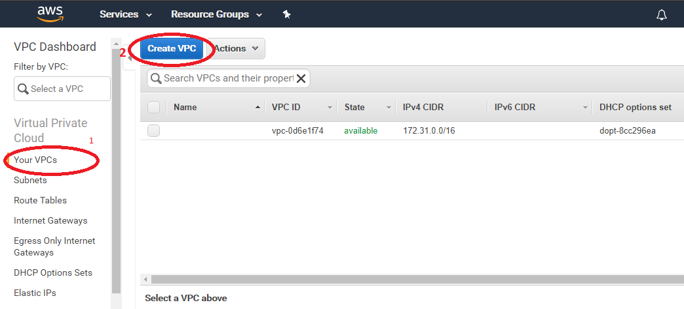

Enter VPC CIDR details as below Name tag: **MyVPC**  
IPv4 CIDR block* : **10.0.0.0/16**

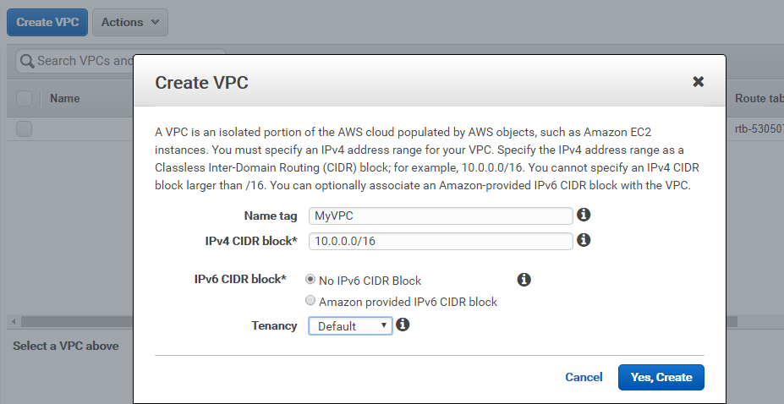

Click “Yes, Create” button.

When will create VPC this will create route table and network ACL automatically.

#### Create Public Subnet

Create a new subnet under custom VPC which you have created.

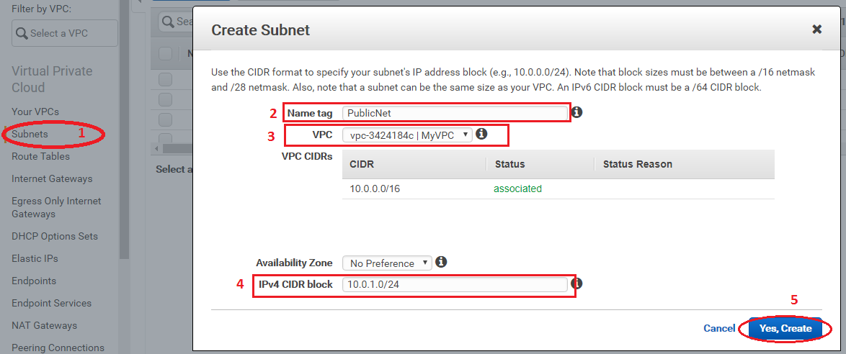

#### Create Private Subnet

Create Private subnet with your VPC.

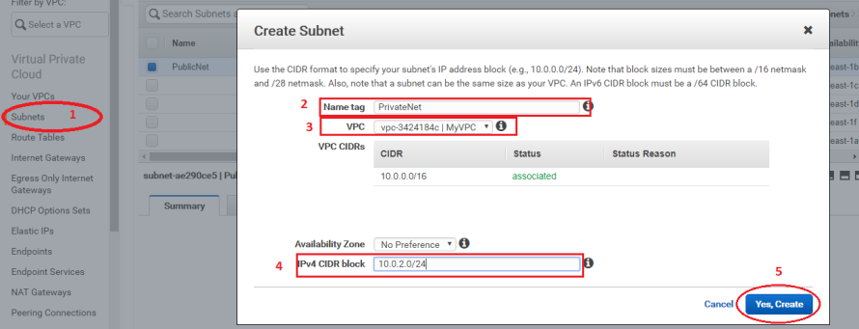

#### Create and Attach “Internet Gateway”

Create new internet gateway and attach to your VPC

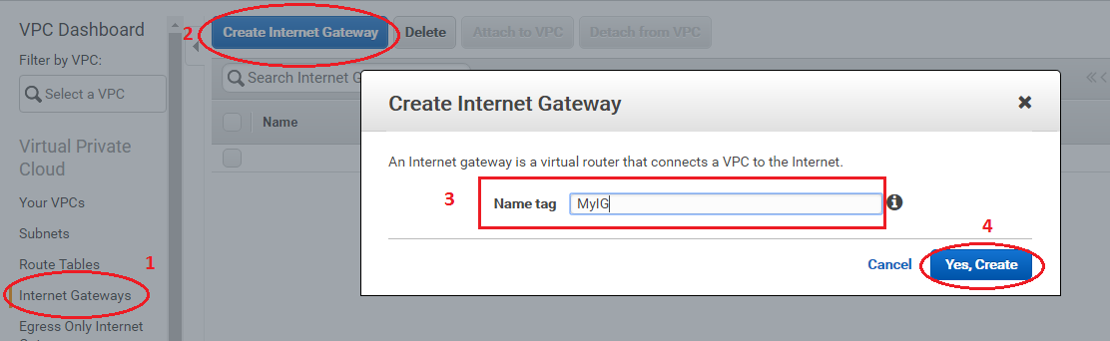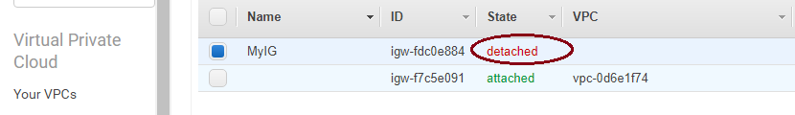

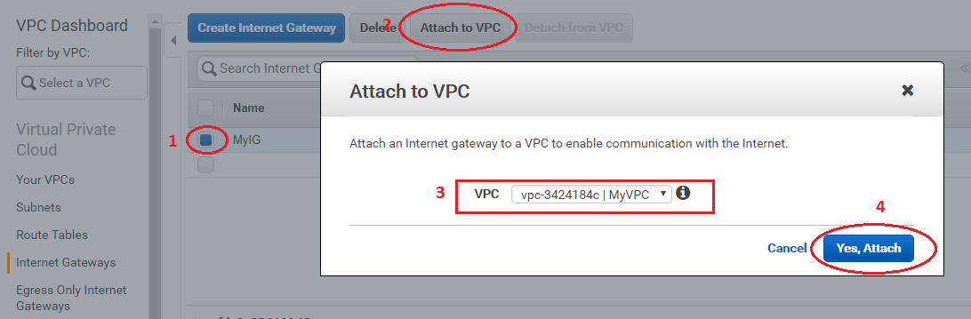

Now internet gateway status will turn into “attached”

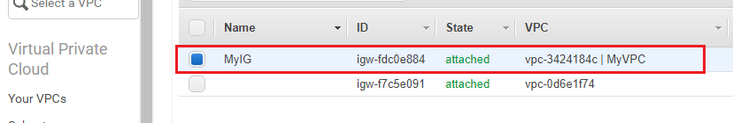

#### Add a route to Public Subnet

Attach subnet (which needs to keep in public interface) to route table.

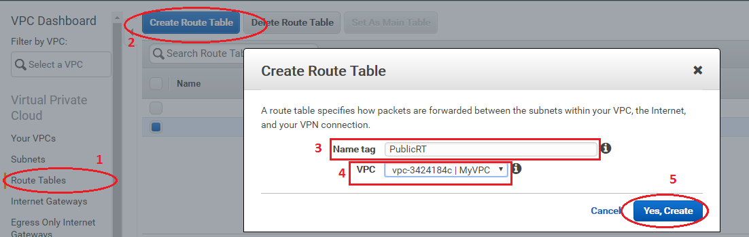

#### Select route table, click on “Routes” then “edit”.

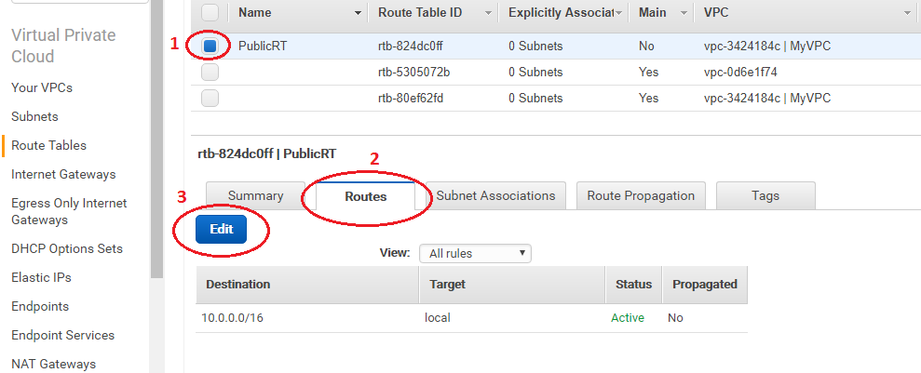

Add “0.0.0.0/0” as “Destination” and click on next box, it should list the “Internet Gateway” that we created before, select it and click on “Save”.

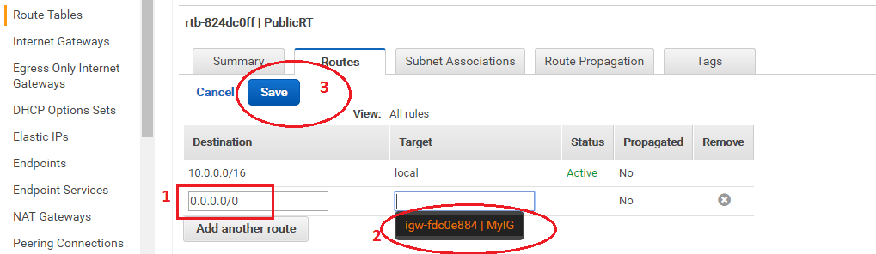

#### Associate this route table with Public subnet

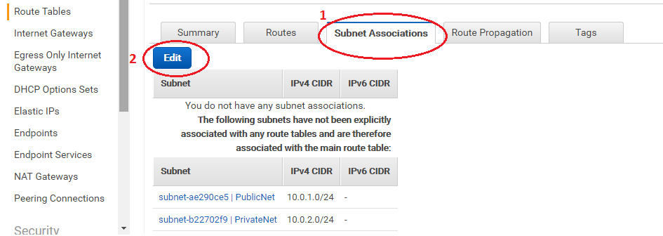

#### Select  “PublicNet” and click “Save”

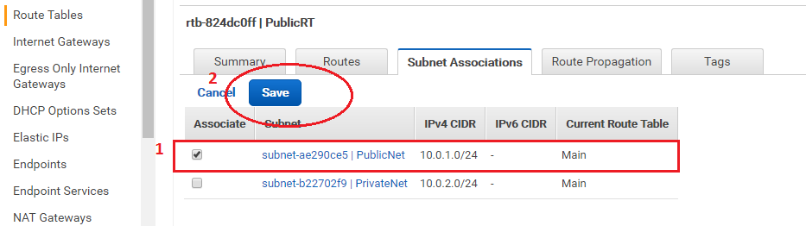

Now you can lunch instance in public subnet which can be access publically depends on security group.

**Note: Don’t’ forget to enable “Public IP” or attached Elastic IP to the instance while you will create instance.**